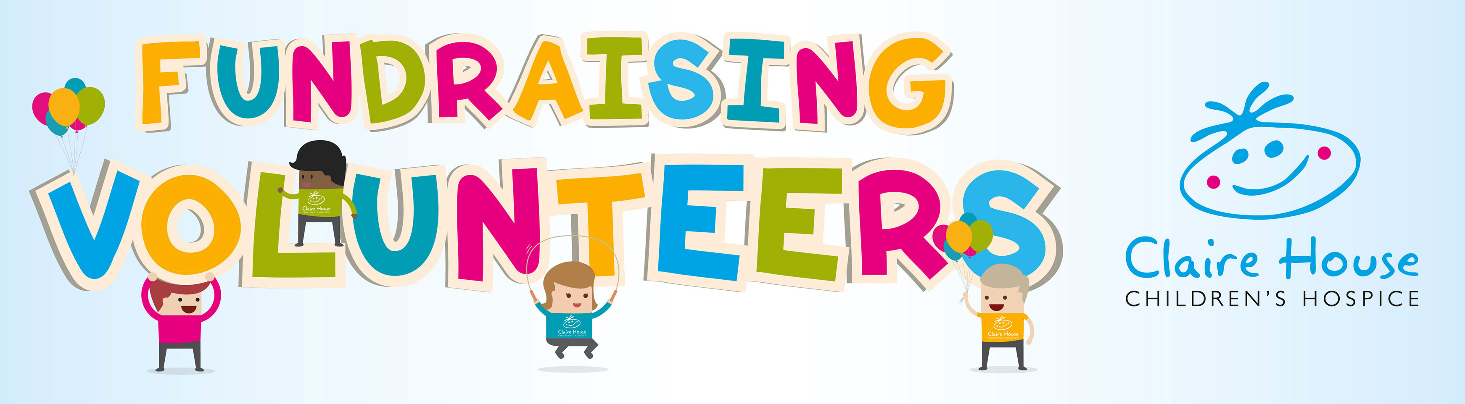

Volunteer
Speaker

Time: Evening / Weekends / Days
Location: Liverpool, Wirral and Cheshire
Reporting to: Community Fundraising Team
About Claire House
Claire House Children’s Hospice offers care, support and choice to families whose children won’t live to be adults. At Claire House, we focus on not what we do, but why we do it. Our nurses take over for a couple of days so mum and dad can be parents, as opposed to carers 24.7.

Purpose of the role:
It is important that, as a local charity, we are out in the community, thanking supporters face to face and inspiring people to donate or fundraise on our behalf but as a small team, this is simply not possible without the help of our Volunteer Speakers.

The role of Volunteer Speaker is:
- To attend group events and speak on behalf of Claire House Children’s Hospice.
- Being the face of Claire House in the local community.
- Helping people to understand what Claire House is all about.
- Giving thanks and telling people about the impact their support has on local families.
- Inspiring new supporters to fundraise for Claire House.
- Helping to link the supporters to the hospice.
- Adding much needed resource to a small team.

Attributes and Competencies:
A Claire House Volunteer Speaker will be an enthusiastic and positive individual. An excellent communicator, who can speak passionately about Claire House and the great services we provide for the children and their families.

What benefits can you expect?
The opportunity to meet a variety of supporters from Girl Guides to Women’s Institutes. To re-gain confidence in public speaking. To have that ‘feel good’ factor of knowing that your time and effort at each event, no matter how small, all contributes to providing the support that Claire House can offer the children and their families at a very difficult time.

Training and Development: | On the task training will be provided and an induction from a member of the fundraising team.
Contact: | If you are interested in applying for this opportunity or would like further information please contact the Community and Volunteer Co-ordinator by telephone 0151 343 0883 or email melissa.henderson@clairehouse.org.uk

